**GIT**

Verify if master is in clean state.

Create a branch “GitWork”. Add a file “hello.xml”.

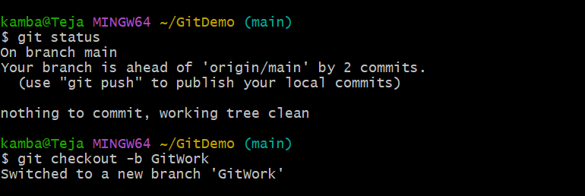

Update the content of “hello.xml” and observe the status

Commit the changes to reflect in the branch

